41.48: The effective field is that which gives rise to the observed difference in the energy level transition,
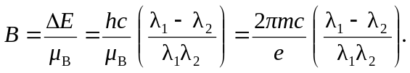
Substitution of numerical values gives 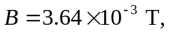 much smaller than that for sodium.

